Sculpture
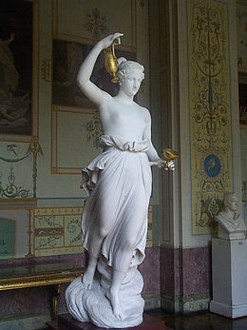
Hebe by Canova (1800–05), in the appropriately neoclassical surroundings of the Hermitage Museum
If Neoclassical painting suffered from a lack of ancient models, Neoclassical sculpture tended to suffer from an excess of them, although examples of actual Greek sculpture of the "classical period" beginning in about 500 BC were then very few; the most highly regarded works were mostly Roman copies. The leading Neoclassical sculptors enjoyed huge reputations in their own day, but are now less regarded, with the exception of Jean-Antoine Houdon, whose work was mainly portraits, very often as busts, which do not sacrifice a strong impression of the sitter's personality to idealism. His style became more classical as his long career continued, and represents a rather smooth progression from Rococo charm to classical dignity. Unlike some Neoclassical sculptors he did not insist on his sitters wearing Roman dress, or being unclothed. He portrayed most of the great figures of the Enlightenment, and travelled to America to produce a statue of George Washington, as well as busts of Thomas Jefferson, Ben Franklin and other luminaries of the new republic.
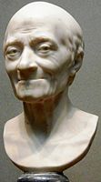Voltaire by Jean-Antoine Houdon, 1778, one of several different versions.

Antonio Canova and the Dane Bertel Thorvaldsen were both based in Rome, and produced portraits of many ambitious life-size figures and groups; both represented the strongly idealizing tendency in neoclassical sculpture. Canova has a lightness and grace, where Thorvaldsen is more severe; the difference is exemplified in their respective groups of the Three Graces. All these, and Flaxman, were still active in the 1820s, and Romanticism was slow to impact sculpture, where versions of Neoclassicism remained the dominant style for most of the 19th century. 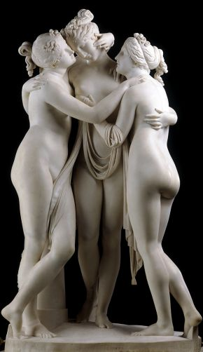
- An early neoclassicist in sculpture was the Swede Johan Tobias Sergel,. 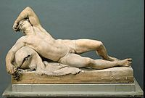
Resting Faun, 1770, Johan Tobias Sergel

John Flaxman was also, or mainly, a sculptor, mostly producing severely classical reliefs that are comparable in style to his prints; he also designed and modelled neoclassical ceramics for Josiah Wedgwood for several years. The late Baroque Austrian sculptor Franz Xaver Messerschmidt turned to Neoclassicism in mid-career, shortly before he appears to have suffered some kind of mental crisis, after which he retired to the country and devoted himself to the highly distinctive "character heads" of bald figures pulling extreme facial expressions. 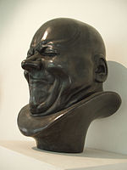
One of the "character heads" of Franz Xaver Messerschmidt

Like Piranesi's Carceri, these enjoyed a great revival of interest during the age of psychoanalysis in the early 20th century. The Dutch neoclassical sculptor Mathieu Kessels studied with Thorvaldsen and worked almost exclusively in Rome.
Since prior to the 1830s the United States did not have a sculpture tradition of its own, save in the areas of tombstones, weathervanes and ship figureheads, the European neoclassical manner was adopted there, and it was to hold sway for decades and is exemplified in the sculptures of Horatio Greenough, Hiram Powers, Randolph Rogers and William Henry Rinehart.

- 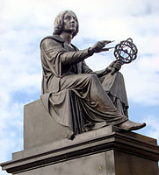
Monument to Copernicus by Thorwaldsen, Warsaw
- 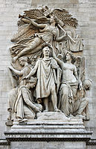
Le triomphe de 1810, Jean-Pierre Cortot, from the Arc de triomphe
- 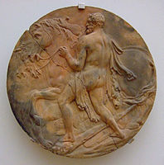
Hercules and the horses of Diomedes, Johann Gottfried Schadow, study for the Brandenberg Gate triumphal arch
- 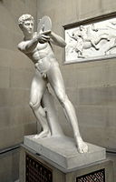
Diskobolos preparing to throw, Mathieu Kessels, Chatsworth House

- 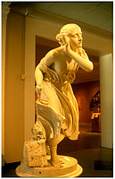
Nydia, Randolph Rogers, 1859

Early Neoclassical Painting (c.1750-80) –
Characteristics
Neoclassicism as expressed in painting developed in different ways to neoclassical sculpture or architecture. The architecturewere based on actual prototypes which had survived from antiquity. But almost no paintings had been found to survive, until, that is, the excavations at Herculaneum and Pompeii.
The earliest painters of the neoclassical school included the Frenchman Joseph-Marie Vien (1716-1809) the Italian portraitist Pompeo Girolamo Batoni (1708-87), the Swiss artist Angelica Kauffmann (1741-1807), and the Scotsman Gavin Hamilton (1723-98), all of whom were active in the 1750s, 60s, and 70s. And while their compositions typically included poses and figurative arrangements from Greek sculpture and vase paintings, they were still strongly influenced by the preceding rococo.
- The style of Kauffmann's pretty, sentimental paintings is barely distinguishable from much rococo art. (Self-Portrait Torn Between Music and Painting, 1792.) 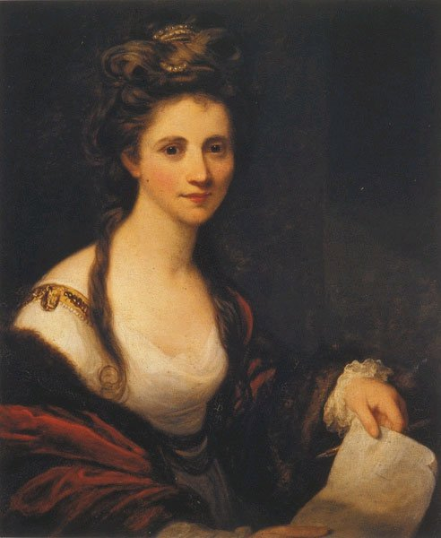
- 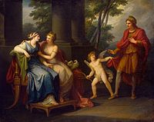
Angelica Kauffman, Venus Induces Helen to Fall in Love with Paris, 1790

Even its classical scenes have a rococo-type lightness. (Cornelia, Mother of the Gracchi, 1785.) The same might be said of the work of Elisabeth Vigee-Lebrun (1755-1842). Another case in point is the neoclassical painting Parnassus (1761; Villa Albani, Rome) by Mengs, which borrowed heavily from 17th-century classicism as well as the High Renaissance master Raphael. Moreover, despite Mengs's apparent agreement with Winckelmann's theory of Greek aesthetics, the style he used in most of his church and palace ceilings was more akin to existing Italian Baroque traditions than to ancient Greece.

Other influences included works by the great Nicolas Poussin (1594-1665), the greatest French painter of the 17th century, whose own brand of classical history painting set the standard in academic art for generations and became the embodiment of French classicism.
It is hard to recapture the radical and exciting nature of early neo-classical painting for contemporary audiences. The drawings, subsequently turned into prints, of John Flaxman as he used very simple line drawing and figures mostly in profile to depict The Odyssey and other subjects, while the history paintings of Angelica Kauffman, mainly a portraitist, are described as having "an unctuous softness and tediousness" Rococo frivolity and Baroque movement had been stripped away but many artists struggled to put anything in their place, and in the absence of ancient examples for history painting, other than the Greek vases used by Flaxman, Raphael tended to be used as a substitute model, as Winckelmann recommended.
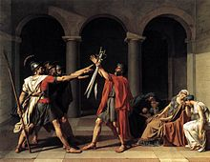
Jacques-Louis David, Oath of the Horatii, 1784
The work of other artists, who could not easily be described as insipid, combined aspects of Romanticism with a generally Neoclassical style, and form part of the history of both movements. Giovanni Battista Piranesi ‘s main subject matter was the buildings and ruins of Rome, and he was more stimulated by the ancient than the modern. The somewhat disquieting atmosphere of many of his views becomes dominant in his series of 16 prints of Carceri d'Invenzione ("Imaginary Prisons") whose "oppressive cyclopean architecture" conveys "dreams of fear and frustration" The Swiss-born Johann Heinrich Füssli spent most of his career in England, and while his fundamental style was based on neoclassical principles, his subjects and treatment more often reflected the "Gothic" strain of Romanticism, and sought to evoke drama and excitement.
Neoclassicism in painting gained a new sense of direction with the sensational success of Jacques-Louis David's Oath of the Horatii at the Paris Salon of 1785. Despite its evocation of republican virtues, this was a commission by the royal government, which David insisted on painting in Rome. David managed to combine an idealist style with drama and forcefulness. The central perspective is perpendicular to the picture plane, made more emphatic by the dim arcade behind, against which the heroic figures are disposed as in a frieze, with a hint of the artificial lighting and staging of opera, and the classical colouring of Nicholas Poussin. David rapidly became the leader of French art, and after the French Revolution became a politician with control of much government patronage in art. He managed to retain his influence in the Napoleonic period, turning to frankly propagandistic works, but had to leave France for exile in Brussels at the Bourbon Restoration.
David's many students included Jean Auguste Dominique Ingres, who saw himself as a classicist throughout his long career, despite a mature style that has an equivocal relationship with the main current of Neoclassicism, and many later diversions into Orientalism and the Troubadour style that are hard to distinguish from those of his unabashedly Romantic contemporaries, except by the primacy his works always give to drawing. He exhibited at the Salon for over 60 years, from 1802 into the beginnings of Impressionism, but his style, once formed, changed little
- 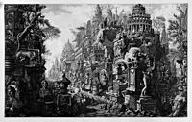
Fantasy depiction of the Appian Way; etching by Giovanni Battista Piranesi, 1756
- 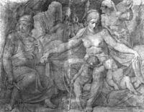
Asmus Jacob Carstens, Night and Her Children, Sleep and Death, 1794, Black chalk on paper, 745 x 985 cm
- 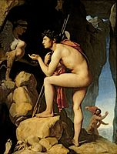
Ingres' version of Neoclassicism, Oedipus and the Sphinx, 1808

Neoclassical interior design
In the visual arts the European movement called "neoclassicism" began after 1765, as a reaction against both the surviving Baroque and Rococo styles, and as a desire to return to the perceived "purity" of the arts of Rome, the more vague perception ("ideal") of Ancient Greek arts, and, to a lesser extent, 16th century Renaissance Classicism.
Indoors, neoclassicism made a discovery of the genuine classic interior, inspired by the rediscoveries at Pompeii and Herculaneum, which had started in the late 1740s, but only achieved a wide audience in the 1760s.
Italy's major centres of Neoclassical art and interior design were Rome, Milan, Naples, Turin and Genoa, whilst Venice was far slower in adopting this new classicist fashion, and Venetian interiors were still Rococo in essence until the 1790s, when they were lightly made more simple and less flamboyant.
Although Neoclassical designs were mainly based on Roman and Renaissance architecture from Italy, and the nation was one of the founders of the style, France and England were the main stylistic leaders of the period, and by that time, Great Britain had deposed France of its position as the cultural and social leader in Europe. Giovanni Battista Piranesi's book, "Diverse Maniere d'Addornare in Cammini" illustrated how he believed Neoclassical interior design to be, and were unique in Europe since they combined the classical style of Neoclassical furnishings with the flamboyancy of the Rococo, creating an elaborate, yet Classical style. His works and ideas proved highly popular in Rome, where they were used as prototypes to furnish the interiors of the Vatican, and later spread throughout the rest of the continent.
Italian Neoclassical furniture was loosely based on that of Louis XVI styles, but was made unique by the usage of exaggeratedly shaped backs and necks which were recessed. Armoires, or armadi made by the Venetians were more geometrically shaped than the Rococo ones, but were usually gilded in gold and silver, and had a few intricate details, such as cartouches. The French encoignure cabinets also proved highly popular in Italian furniture. French style secretaire writing tables were also popular in Italian furnishings, but were made uniquely Italian by adding pietra dura intricate designs on the marble slabs which covered the writing desks. Italian commodes and console tables were still relatively similar to before, yet they were more classical in style, and rather than having cabriole legs usually had elegantly decorated straight, demi-lune at most, legs.
Armachairs made in Italy were based on the French Louis XVI-esque fauteils, but were made unique by adding gilded gold and many precious and exotic decorations, such as stones and jewels etc Since there was a severe shortage of high-quality woods such as walnut, most furnishings were gilded in order to cover some of the low-quality materials used
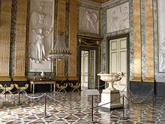
One of the Neoclassical rooms of the Palace of Caserta.
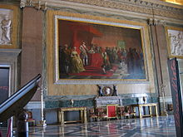
Another Neoclassical room in the Palace of Caserta.
Neoclassical furniture
Neoclassical furniture is a style of furniture that gained popularity in the mid-1700s and into the 1800s. Many countries followed the neoclassical design during that time period, each one giving the style a different name. As a result, in England neoclassical furniture is referred to as Late Georgian, in France it is called Louis XVI style, and in the United States it is called the Federal or Empire style. It is also called Grecian or Etruscan style in some places.
Interestingly, neoclassical furniture came about as a result of the excitement fostered when ruins were uncovered in Herculaneum and Pompeii in the mid-1700s. The people at that time became enthralled with the ancient civilizations of Rome and Greece. They even began to model their furniture after the furnishings that were used in these ancient cities. Thus, neoclassicism began.
In neoclassical furniture, form is ultimately the most important factor. The furniture should be considered orderly, with more tidy lines and fewer swirls and curves. There is still plenty of ornate detail, as was common in previous furniture styles, however. The detail in neoclassical furniture comes from delicate painting and precise carving. In addition, wood can be inlaid with other pieces of wood, gold foil, or other materials.
Popular pieces of neoclassical furniture include the chaise lounge, similar to the one in which Cleopatra was so often depicted relaxing; fire screens; chairs; sofas; footstools; tables; and bookcases. Many times, room accessories are often used to carry out the theme in a room as well. These often include statutes and fountains, as both are reminiscent of ancient Greece or Rome.

Mirrors
The Venetians were still the main glass and mirror-makers in Italy, and produced amongst the best in the world Venetian mirrors changed little during the Neoclassical period, and still had several cartouches and were often gilded. However, the shape of their girandole changed from being round to oblong.

Console tables
Console tables in Italy radically changed after the 1760s and 1770s. They were usually far plainer and more classical in style, with grand marble slabs and straight legs, which were often bulky and heavily decorated But, at the same time, Venetian console tables were still mainly inspired by the Louis XV designs, but usually had plainer and simpler cabriole legs.

Armchairs
Italian armchairs during the Neoclassical period made a return to the Baroque style, with heavy and bulky straight legs and sculptural carvings. They were usually quite bold, and Venetian and Genoese ones were often gilded, whilst Milanese armchairs were mainly left untouched.
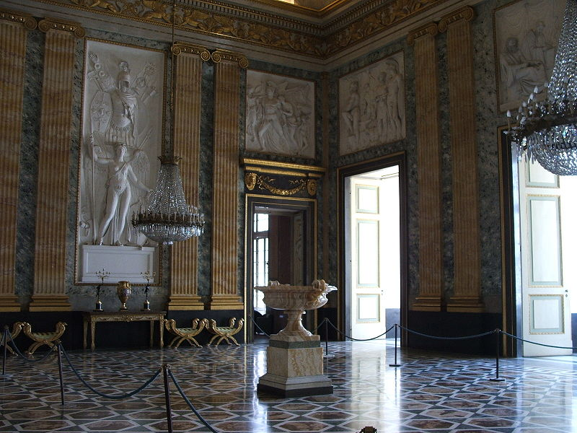
- Neoclassical elegance in the Palace of Caserta.

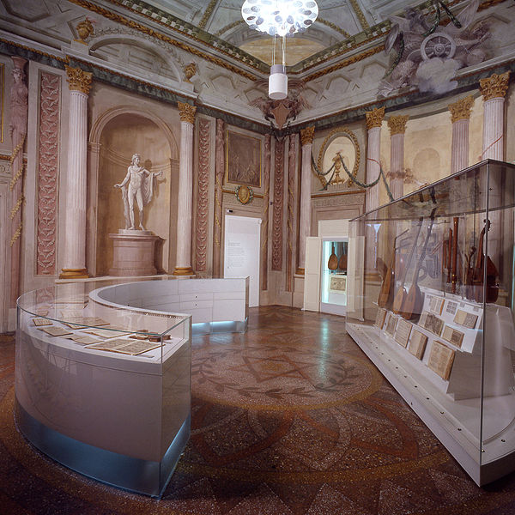
- The "Sala della Musica" (Music Hall) in the Bologna Library.

